**­­** MAJOR PROJECT REPORT

ON

**fake currency detection using**

**image processing**

Submitted in partial fulfillment of the requirements

For the award of the degree of

**BACHELOR OF TECHNOLOGY**

**IN**

**ELECTRONICS AND COMMUNICATION ENGINEERING**

Submitted By

**MADHUR JOSHI MANAN KANSWAL PIYUSH CHANDEL**

*(03596202818) (03696202818) (05096202818)*

**Under the guidance of**

Ms. AAKANKSHA GUPTA, ASSISTANT PROFESSOR, ECE department



**Department of Electronics & Communication Engineering Dr. Akhilesh Das Gupta Institute of Technology & Management**

**(Guru Gobind Singh Indraprastha University, Dwarka, Delhi).**

**Delhi -110053.**

**MAY- 2022.**

**CERTIFICATE**

We hereby certify that the work that is being presented in the project report entitled “**Fake Currency Detection using Image Processing”** to the partial fulfillment of the requirements for the award of the degree of **Bachelor of Technology in Electronics & Communication Engineering from Dr. Akhilesh Das Gupta Institute of Technology & Management**, New Delhi. This is an authentic record of our own work carried out during a period from Feb 2022 to May 2022 under the guidance of **Ms.** **Aakanksha Gupta, Assistant Professor ECE department.**

The matter presented in this project has not been submitted by us for the award of any other degree elsewhere.

**MADHUR JOSHI MANAN KANSWAL PIYUSH CHANDEL**

*(03596202818) (03696202818) (05096202818)*

This is to certify that the above statement made by the candidate is correct to the best of my knowledge. They are permitted to appear in the Major Project External Examination.

**Ms. AAKANKSHA GUPTA Prof. (Dr.) Niranjan Bhattacharya**

**ASSISTANT PROFESSOR HOD, ECE**

**Mr. Devraj Gautam** **(Signature of External Examiner)**

**Project Coordinator, ECE Deptt.**

**ACKNOWLEDGEMENT**

We would like to acknowledge the contributions of the following persons, without whose help and guidance this report would not have been completed.

We acknowledge the counsel and support of our project guide **Ms. Aakanksha Gupta, Assistant Professor, ECE department,** with respect and gratitude, whose expertise, guidance, support, encouragement, and enthusiasm has made this report possible. Their feedback vastly improved the quality of this report and provided an enthralling experience. We are indeed proud and fortunate to be supervised by him.

We are thankful to **Prof.** (**Dr.) Niranjan Bhattacharya**, **H.O.D. ECE department, Dr. Akhilesh Das Gupta Institute of Technology & Management, New Delhi** for his constant encouragement, valuable suggestions and moral support and blessings.

We are immensely thankful to our esteemed, **Prof. (Dr.) Sanjay Kumar, Director, Dr. Akhilesh Das Gupta Institute of Technology & Management, New Delhi** for his never-ending motivation and support.

We shall ever remain indebted to **Mr. Devraj Gautam, Project Coordinator ECE department** and faculty and staff members of Dr. Akhilesh Das Gupta Institute of Technology & Management, New Delhi.

Finally, yet importantly, We would like to express our heartfelt thanks to God, our beloved parents for their blessings, our friends/classmates for their help and wishes for the successful completion of this project.

**MADHUR JOSHI MANAN KANSWAL PIYUSH CHANDEL**

*(03596202818) (03696202818) (05096202818)*

**Dr. Akhilesh Das Gupta Institute of Technology & Management**

**Electronics and Communication Engineering**

|  |  |
| --- | --- |
| **Vision Of Department :** To produce World class Electronics & Communication  Engineers through academic excellence and innovations, who would be competent Technocrats with work ethics to meet the needs of the society | |
| **Mission of Department** | **Program Educational Objectives (PEOs)** |
| **M1.** To impart quality education for excelling in the field of Electronics & Communication Engineering to face real world challenges in existing and emerging domains. | ***PEO1:*** Graduates shall excel in the field of electronics and communication engineering by applying their acquired knowledge and skills to develop feasible and viable solutions to engineering challenges of the country. |
| **M2.** To provide a creative platform for promotion of innovations in the field of Electronics & Communication Engineering by keeping close proximity to industry. | ***PEO2:*** Graduates shall be adaptive to innovations and new technologies which shall lead them to professional excellence. |
| **M3.** To provide conducive environment for development of work ethics and prepare socially  responsible citizens. | ***PEO3:*** Graduates shall manage resources skillfully and practice the profession with ethics, integrity and social responsibility. |

**ABSTRACT**

Since last few years, as a result of the great technological advances in color printing, duplicating and scanning, counterfeiting problems have become more and more serious. In the past, only the printing house has the ability to make counterfeit note, but today it is possible for any person to print counterfeit bank notes simply by using a computer and a laser printer at house. Therefore, the issue of efficiently verifying counterfeit banknotes from real ones via automatic machines has become more and more important [5].

Counterfeit notes are a problem of almost every country but India has been hit really hard and has become a very acute problem. There is a need to design a system that will helpful for recognition of paper currency notes with fast speed and in less time. This proposed system describes an approach for verification of Indian banknotes. The currency will be checked out by using image processing techniques.

The approach consists of a number of elements including processing of image, detection of edge, image segmentation, drawing out characteristic, comparing both images. The image processing approach is discussed with MATLAB to verify the parameters of note. Image processing involves changing the nature of an image in order to improve its visual information for human interpretation. The image processing software is a collection of functions that extends the capability of the MATLAB numeric computing environment [12]. **TABLE OF CONTENTS**

Certificate i

Acknowledgement ii

Vision Of Department iii

Abstract iv

Table of Contents v

List of Figure vi

**CHAPTER 1: INTRODUCTION AND LITERATURE REVIEW**

* 1. Introduction 1
  2. Basic terms of project (Project Based upon ) 3
  3. Literature Overview 6
  4. Motivation 7
  5. Organization of Project Report 8

**CHAPTER 2: METHODOLOGY ADOPTED**

* 1. Methodology 11
  2. Working 13

**CHAPTER 3: DESIGNING AND RESULT ANALYSIS**

3.1 Design of this Project 16

3.2 Result and Analysis 17

**CHAPTER 4: MERITS, DEMERITS AND APPLICATIONS**

4.1 Merits 18

4.2 Demerits

4.3 Applications

**CHAPTER 5: CONCLUSIONS AND FUTURE SCOPE**

5.1 CONCLUSION 20 5.2 FUTURE SCOPE 21

**REFERENCES** 22

**APPENDIX** 23

**List of Figures**

|  |  |  |
| --- | --- | --- |
| **Figure No.** | **Title of Figure** | **Page** |
| 1. | RBI | 2 |
| 2. | Matlab logo | 4 |
| 3. | Flowchart | 5 |
| 4. | Detailed Representation of a note | 10 |
| 5. | Flow Diagram Of Process | 12 |
| 6. | Image Acquisition | 13 |
| 7. | Grey Scale Image | 13 |
| 8. | Edge based segmentation | 14 |
| 9. | Edge based segmentation of security thread | 14 |
| 10. | Edge based segmentation of serial number | 15 |
| 11. | Flow chart for decision making | 16 |
| 12. | Testing a genuine 500 denomination note | 17 |
| 13. | Testing a fake 500 denomination note | 17 |

**CHAPTER 1:**

**INTRODUCTION AND LITERATURE REVIEW**

**1.1 INTRODUCTION**

In the 21st century, digital technologies, such as complex scanners, copiers, and computer software, have vastly increased one’s ability to counterfeit just about anything. For instance, even students can manufacture bank notes realistic enough to fraudulently purchase school lunch. Money, stamps, checks, coupons, IDs, signatures and product labels have become the subject of ever- increasingly sophisticated counterfeiting techniques [2].

In order to diminish such an illegal phenomenon, we propose to develop a system that can be integrated into scanners, copiers, and other electronic equipment frequented by counterfeiters. With current technology, fake money is within reach of even average citizens; with the “Can’t Copy This”, authorities could begin to curb counterfeiting among the masses. We plan to combat this problem through the application of image processing and pattern recognition. The Central Bank Counterfeit Deterrence Group (CBCDG) has already organized hardware and software manufacturers to fight this problem through the development of the Counterfeit Deterrence System (CDS) [7].

Despite this, people are able to outwit these safeguards and utilize commercial products to counterfeiting currency. Therefore, more robust solutions are required. Some pre-existing efforts, in coordination with the CBCDG, have found their way into the mainstream [5]. Current versions of Adobe Photoshop, Jasc Paint Shop Pro, and similar software have integrated simple schemes to thwart counterfeiters. Printers in Japan are required to have embedded features to place microscopic dots on all their printouts that indicate their sources through identifying serial numbers. While the details of these schemes are unknown, they have proven to be less than perfect since counterfeiting still presents to be an issue nowadays.

A different approach pursued by Media Sec Technologies involves embedding special (invisible) images on product labels and CDs to enable a scanning device to differentiate real products from fake look-alike [1].

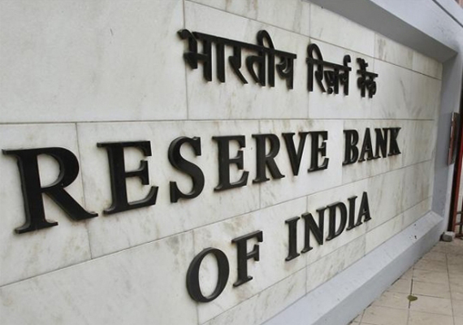

Fig-1: RBI

**1.2 Basic Terms Of Project :**

**1.2.1 Matlab**

**MATLAB** (an abbreviation of "MATrix LABoratory") is a [proprietary](https://en.wikipedia.org/wiki/Proprietary_software) [multi-paradigm](https://en.wikipedia.org/wiki/Multi-paradigm_programming_language) [programming language](https://en.wikipedia.org/wiki/Programming_language) and [numeric computing](https://en.wikipedia.org/wiki/Numerical_analysis) environment developed by [MathWorks](https://en.wikipedia.org/wiki/MathWorks" \o "MathWorks). MATLAB allows [matrix](https://en.wikipedia.org/wiki/Matrix_(mathematics)) manipulations, plotting of [functions](https://en.wikipedia.org/wiki/Function_(mathematics)) and data, implementation of [algorithms](https://en.wikipedia.org/wiki/Algorithm), creation of [user interfaces](https://en.wikipedia.org/wiki/User_interface), and interfacing with programs written in other languages.

Although MATLAB is intended primarily for numeric computing, an optional toolbox uses the [MuPAD](https://en.wikipedia.org/wiki/MuPAD" \o "MuPAD) [symbolic engine](https://en.wikipedia.org/wiki/Computer_algebra_system) allowing access to [symbolic computing](https://en.wikipedia.org/wiki/Symbolic_computing) abilities. An additional package, [Simulink](https://en.wikipedia.org/wiki/Simulink), adds graphical multi-domain simulation and [model-based design](https://en.wikipedia.org/wiki/Model-based_design) for [dynamic](https://en.wikipedia.org/wiki/Dynamical_system) and [embedded systems](https://en.wikipedia.org/wiki/Embedded_system) [3].

MATLAB® combines a desktop environment tuned for iterative analysis and design processes with a programming language that expresses matrix and array mathematics directly. It includes the Live Editor for creating scripts that combine code, output, and formatted text in an executable notebook.

**Professionally Built**

MATLAB toolboxes are professionally developed, rigorously tested, and fully documented.

**With Interactive Apps**

MATLAB apps let you see how different algorithms work with your data. Iterate until you’ve got the results you want, then automatically generate a MATLAB program to reproduce or automate your work.

**And the Ability to Scale**

Scale your analyses to run on clusters, GPUs, and clouds with only minor code changes. There’s no need to rewrite your code or learn big data programming and out-of-memory techniques [5].



Figure-2: Matlab logo

**1.2.2 Image Processing Toolbox**

Image Processing Toolbox provides a comprehensive set of reference-standard algorithms and workflow apps for image processing, analysis, visualization, and algorithm development. You can perform image segmentation, image enhancement, noise reduction, geometric transformations, image registration, and 3D image processing [6].

Image Processing Toolbox apps let you automate common image processing workflows. You can interactively segment image data, compare image registration techniques, and batch-process large data sets. Visualization functions and apps let you explore images, 3D volumes, and videos; adjust contrast; create histograms; and manipulate regions of interest (ROIs).

You can accelerate your algorithms by running them on multicore processors and GPUs. Many toolbox functions support C/C++ code generation for desktop prototyping and embedded vision system deployment [11].

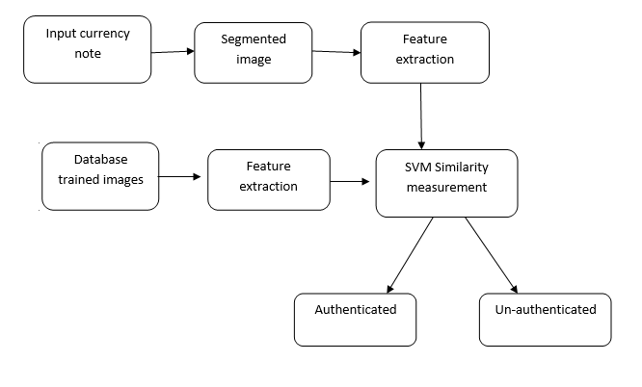

Figure-3: Flowchart [4]**1.3 LITERATURE OVERVIEW**

Fraud detection technique by using performance metrics is used in this paper. This method is used to detect credit card fraud, computer intrusion and tele-communication fraud. Neural networks and model based reasoning are the two methods behind this technique. The general attributes like identification mark and serial numbers of currency are extracted.[7] Denomination of currency is known by identification mark. Next generation intrusion detection expert system is used in this paper by using the real time and batch technique. Large volume of fake money will cause many problems. Using machine it is easy to recognize fake currency [9].

Every year RBI (Reserve Bank of India) face the fake money or destroyed money. Various methods like water marking, optically variable ink, florescence, etc. are used to detect fake currency in this paper. In this system, various two components of two images are combined together to find the variation among the images. Image acquisition, gray scale conversion, edge detection, feature extraction, image segmentation and comparison of images are the methods used in this approach to detect the fake currency. Feature extraction by edge based segmentation using soble operator is used in this paper for design and implementation. The image is acquired and the acquired image is converted into grey scale by pixel value . The image is sub divided into object or region by image segmentation. Security features of Indian currency are used in this paper [12].

**1.4 MOTIVATION**

The main motivation behind development of this project was to make a system for easy and quick detection of genuine and fake currency notes. This is a MATLAB based system for automatic recognition of security features of currency.

The main objective of the project is to identify the fake Indian currency notes automatically using Morphological Algorithm. Although there were many methods in existence, this method was designed to overcome the drawbacks of the previous methods. This method gives a faster and more accurate output when compared to the other techniques [8].

**1.5 Organization of Project Report**

**a) Image Acquisition**

In the proposed work, the image will be acquired by using simple digital camera by providing some backlighting so that all the features of the currency can appear on the image properly. The image is then stored in the computer for further processing. Image acquisition is the creation of digital images, typically from a physical scene. Edge detection and feature extraction are the most important tasks performed on the images.

**b)** **Grayscale Conversion**

A grayscale digital image is an image in which the value of each pixel is a single sample, it carries only intensity information. Images of this sort, also known as black and white, are composed exclusively of shades of gray, varying from black at the weakest intensity to white at the strongest. Conversion of a color image to gray scale is not unique ,different weighing of the color channels if actively represent the effect of shooting black and white film with different colored filters.

**c)** **Edge Detection**

Edge detection is a fundamental tool in image processing and computer vision, particularly in the areas of feature detection and feature extraction, which aim at identifying points in a digital image at which the image brightness changes sharply or, more formally, has discontinuities. Edge detection is one of the fundamental steps in image processing, image analysis, image pattern recognition, and computer vision techniques.

**d)** **Feature Extraction**

Feature extraction is very different from feature selection. It starts from an initial set of measured data and builds derived values (features) intended to be informative, non redundant,facilitating the subsequent learning and generalization steps leading to better interpretations. It is related to dimensionality reduction. The extracted features are expected to contain the relevant information from the input data, so that the desired task can be performed using this reduced representation instead of the complete initial data .Many data analysis software packages provide for feature extraction and dimension reduction. common numerical programming environments such as MATLAB, SciLac, NumPy and the R language provide some of the simple feature extraction technique via built in commands.

**i) Identification Mark**

A symbol with intaglio prints which can be felt by touch,helps the visually impaired to identify the denomination. In500 denominations the identification mark is a circle. In 1000denominations the identification mark is a diamond.

**ii) Security Thread**

It is a 3.00 mm wide strip with inscriptions “.art” and “RBI”

and color shift from green to blue when viewed from different angles. The thread is visible as a continuous line from behind when held up against light.

**iii) Latent image**

It is a vertical band on front side of denomination at right hand side. It contains latent image showing the numeral of the denomination when the banknote is held horizontally at eyelevel.

**iv) Watermark**

The portrait of Mahatma Gandhi, the multidirectional lines and on electrolyte mark showing the denominational numeral appear in this section and these can be viewed better when the banknote is held against light.

**v) Number Panel**

A special, unique and distinct font is used. The spaces between the numbers are evenly distributed. The numbers are thick and bold in red color. In Rs.1000 note the numbers in the right top corner printed in bluish black color and the left bottom in red.

**vi) Micro lettering**

This feature appears between the vertical band and Mahatma Gandhi portrait. It always contains the word „RBI‟ in Rs.5 and Rs.10. The notes of Rs.20 and above also contain the denominational value of the notes in micro letter. This feature can be seen well under a magnifying glass.

**vii) Intaglio printing**

The portrait of Mahatma Gandhi, the Reserve Bank seal, guarantee and promise clause, Asoka Pillar Emblem on the left, RBI Governor's signature are printed in intaglio i.e. in raised prints, which can be felt by touch, in Rs.20,Rs.50,Rs.100, Rs.500 and Rs.1000 notes.

**viii) Fluorescence**

Number panels of the notes are printed in fluorescent ink. The notes also have optical fibers. Both can be seen when the notes are exposed to ultra-violet lamp [6].

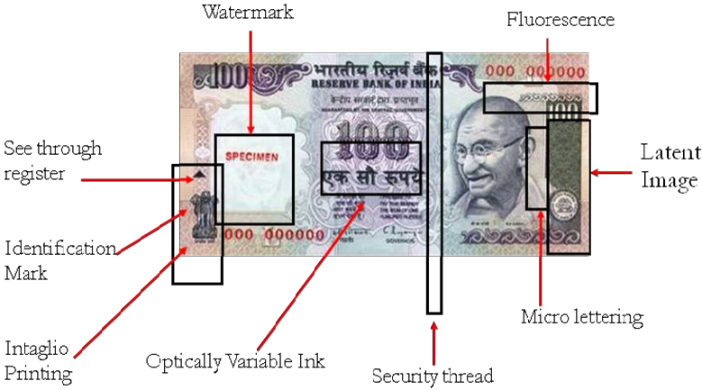

Figure-4: Detailed Representation of a note[11]

**CHAPTER 2:**

**METHODOLOGY ADOPTED**

**2.1 Methodology**

The system proposed here work here on the image of currency note under ultraviolet light acquired by a digital camera. The algorithm which is applied here is as follows **:**

**1.** Acquisition of image of currency note under ultraviolet light by simple digital camera or scanner.

**2.** Image acquired is RGB image and now is converted to grayscale image.

**3.** Edge detection of whole gray scale image.

**4**. Now characteristics features of the paper currency will be cropped and segmented.

**5**. After segmentation, characteristics of currency note are extracted.

**6**. Intensity of each feature is calculated.

**7.** If the condition is satisfied, then the currency note is said as original otherwise fake.[8]

In this method, characteristics of currencies are employed which are used by common people for differentiating for different banknote denomination. The characteristics that can be used to check the authentication of currency note are **:**

**A. Security Thread** It is a 3mm windowed security thread with inscriptions of India in Hindi, RBI and 2000/500 on banknotes with color shift. Color of the thread changes from green to blue when the note is tilted.

**B. Serial Number** Serial number panel with banknote number growing from small to big on the top left side and bottom right side.

**C. Latent image** A vertical band on front side of denomination at right hand size. It contains latent image showing numeral of denomination when banknote is held horizontally at eye level.

**D. Watermark** The portrait of Mahatma Gandhi, and multidirectional lines and a mark showing the denominational numeral appear which can be viewed when held against light.

**E.** Identification Mark A mark with intaglio print which can be felt by touch, helps blind person to identify the denomination. In 500 denomination the mark is of five lines while in 2000 line the mark is of seven lines.[8]

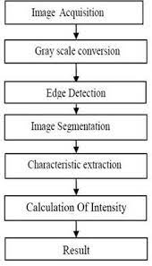

Figure 5: Flow Diagram Of Process [8]

**2.2 Working**

**1) Image acquisition:** The image is kept under ultraviolet light and the image is captured through a simple camera.

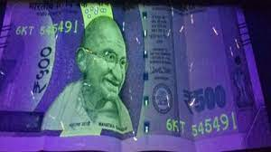

Figure 6 : Image Acquisition [3]

**2) Image preprocessing:** It involves the operations required prior to data analysis and information extraction. Here image resizing is done.

**3) Gray scale conversion and edge detection:** The acquired image is obtained as RGB image which is now converted into gray scale image since it carries intensity information. This image is further processed and edges of gray scale images are detected.

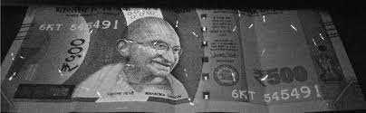

Figure 7 : Grey Scale Image [3]

**4) Image segmentation:** It’s the process of dividing image into multiple parts by cropping it.

**5) Feature extraction:** Now the features are extracted using edge - based segmentation.

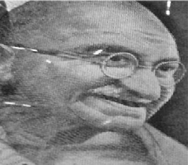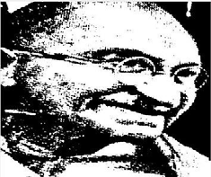

Figure 8**:** Edge based segmentation of Mahatma Gandhi portrait [3]

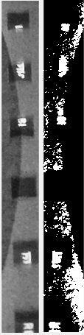

Figure 9**:** Edge based segmentation of security thread [3]

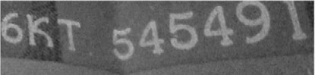

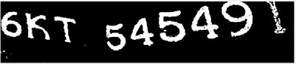

Figure 10: Edge based segmentation of serial number [3]

**6)** Now the process of calculation of intensity of each extracted feature is done. If the calculated intensity is greater than the threshold of 70%, then it is classified as original note otherwise it is considered as fake one.

**7)** The final decision depends upon the intensities of all extracted features.[12]

**CHAPTER 3:**

**DESIGNING AND RESULT ANALYSIS**

**3.1 DESIGN OF THIS PROJECT**

We performed various iterations for testing our work indifferent environment and with a different input each time to estimate the accuracy of our work. The implementation to areal system ensures the following important points-

1. The probability of correct result that is accuracy four system is about 95%.

2. It is low cost system as compare to others.

3.The processing time of the system is very less as the algorithms are not so complex [4].

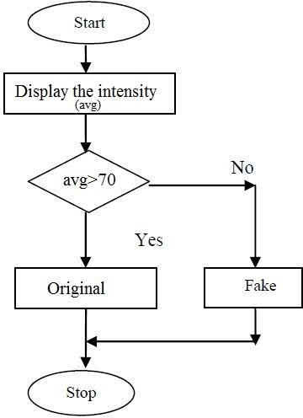

Figure 11:Flow chart for decision making [7]

**3.2 RESULT AND ANALYSIS**

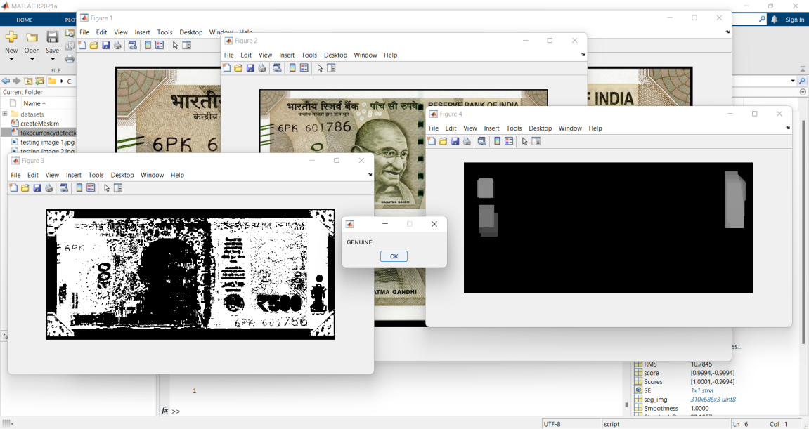

Figure 12: Testing a genuine 500 denomination note

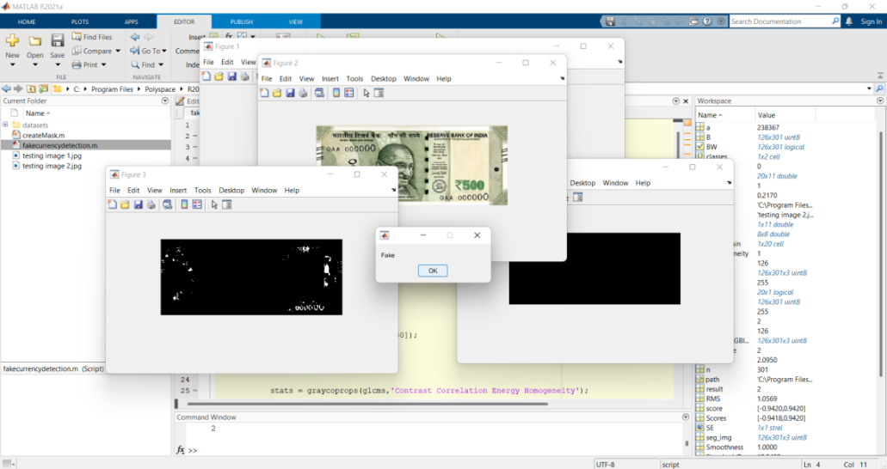

Figure 13:Testing a fake 500 denomination note

**CHAPTER 4:**

**MERITS, DEMERITS AND APPLICATIONS**

**4.1 MERITS :**

* Simplicity.
* High performance speed.
* User friendly.

**4.2 DEMERITS :**

* For our proposed algorithm to work, the image of ROI on the note must be taken in relatively dark conditions , so that the UV light illuminated features are easily discernable .

**4.3 APPLICATIONS :**

* Reduce rotation fake currency.
* User friendly.
* Can be used in shop.
* Automatic machine which can detect banknotes are now widely used in dispensers of modern products like candies, soft drinks bottle to bus or railway tickets [7].

**CHAPTER 5 :**

**CONCLUSION AND FUTURE SCOPE**

**5.1 CONCLUSION**

The fake currency detection using image processing was implemented on MATLAB. Features of currency note like serial number, security thread, Identification mark, Mahatma Gandhi portrait were extracted. The process starts from image acquisition to calculation of intensity of each extracted feature. The system is capable of extracting features even if the note has scribbles on it [4]. The algorithm processed here works suitably for the newly introduced denomination. Hardware implementation of the proposed system can also be done using suitable processor so that to increase the speed of detection. An automatic railway ticket booking system can also be proposed which includes currency detection as one of its part.

There are many methods for identifying a fake note which we have discussed and each one has its own significance. One should caution while detecting a note. This enable a layman to identify a fake note and empower every citizen to detect fake notes which may reduce corruption in our country [9].

**5.2 FUTURE SCOPE**

MATLAB is predominantly used for Simulation purpose, to de- sign algorithms and test mathematical models for hardware implementation like Signal processing that can run one-time operations for large data sets. Mat-lab specializes in Matrix operations which is very important for researchers to modify its features for its high performance measures [12].

**REFERENCES**

[1] Trupti Pathrabe G and Swapnili Karmore 2011 Int. J. CompTrends Tech 152-156 .

[2] Tanaka M, Takeda F, Ohkouchi K and Michiyuk 1998 IEEE Tran on Neural Network 1748- 53.

[3] Jahangir N, Ahsan Raja Chowdhury 2007 IEEE 10th Int. Conf. on Computer and Information Technology 1-5.

[4] Rubeena Mirza, Vinti Nanda 2012 IFRSA Int.J. Computing 2 375-80

[5] Junfang Guo, Yanyun Zhao and Anni Cai 2010 Proc IEEE Int. Conf Network Infrastructure and Digital Content 359-363.

[6] H.Hassanpour, A.Yaseri and G.Ardeshiri “Feature Extraction for Paper Currency Recognition”present this paper at IEEE computer society in 2007.

[7] Vipin Kumar Jain“Indian Currency Denomination Identification Using Image Processing Technique” presented this report at (IJCSIT) International Journal of Computer Science and Information Technologies, Vol. 4 (1) , 2013, 126 –128.

[8] S. Surya1, G. Thailambalproposed“Comparative Study on Currency Recognition System Using Image Processing” this paper in International Journal Of Engineering And Computer Science ISSN:2319-7242 Volume - 3 Issue - 8 August, 2014.

[9] Hanish Agarwal, Padam Kumar, "Indian currency note denomination recognition in color images", IJACEC, Vol. 1, ISSN 2278–5140.

[10] Sanjana, Manoj Diwakar, Anand Sharma, "An Automated recognition of Fake or Destroyed Indian currency notes in Machine vision", IJCSMS, Vol. 12, April

2012.

[11] Euisun Choi, Jongseok Lee and Joonhyun Yoon,"Feature Extraction for Bank Note Classification Using Wavelet Transform”2006 @ISBN ISSN: 1051-4651,

0-7695-2521-0, IEEE.

[12] Peng Wang and Peng Liu, ″Invariant Features Extraction for Ba nknote Classification “Proceedings of the 11th J oint Conference on Information

Sciences@2008.

**APPENDIX**

**Fakecurrencydetection.m**

%%

clc;

clear all;

close all;

cd datasets

df=[]

for i = 1:20

i

B=imread(strcat(int2str(i),'.jpg'));

I=imresize(B,0.5);

%%%%%%%%color%%%%%%%%%%%

%%%%%[BW,maskedImage] = segmentImage(RGB);

[BW,maskedRGBImage] = createMask(I);

seg_img = maskedRGBImage;

B = rgb2gray(seg_img);

SE = strel('rectangle',[40 30]);

img=imopen(B,SE);

glcms = graycomatrix(img);

stats = graycoprops(glcms,'Contrast Correlation Energy Homogeneity');

Contrast = stats.Contrast;

Energy = stats.Energy;

Homogeneity = stats.Homogeneity;

Mean = mean2(seg_img);

Standard_Deviation = std2(seg_img);

Entropy = entropy(seg_img);

RMS = mean2(rms(seg_img));

%Skewness = skewness(img)

Variance = mean2(var(double(seg_img)));

a = sum(double(seg_img(:)));

Smoothness = 1-(1/(1+a));

% Inverse Difference Movement

m = size(seg_img,1);

n = size(seg_img,2);

in_diff = 0;

for i = 1:m

for j = 1:n

temp = seg_img(i,j)./(1+(i-j).^2);

in_diff = in_diff+temp;

end

end

IDM = double(in_diff);

Fr = horzcat(1,[Contrast,Energy,Homogeneity, Mean, Standard_Deviation, Entropy, RMS, Variance, Smoothness, IDM]);

df=[df;Fr];

end

cd ..

%%

%%%%%%%%%%%%get test image %%%%%%%%%%

[fname,path]=uigetfile('.jpg','Provide currency for testing');

filename=strcat(path,fname);

B=imread(filename);

imshow(B),figure

I=imresize(B,0.5);

imshow(I);

figure

title('Original Image');

[BW,maskedRGBImage] = createMask(I);

seg_img = maskedRGBImage;

imshow(BW);

figure

imshow(maskedRGBImage)

B = rgb2gray(seg_img);

SE = strel('rectangle',[40 30]);

img=imopen(B,SE);

imshow(img)

glcms = graycomatrix(img);

stats = graycoprops(glcms,'Contrast Correlation Energy Homogeneity');

Contrast = stats.Contrast;

Energy = stats.Energy;

Homogeneity = stats.Homogeneity;

Mean = mean2(seg_img);

Standard_Deviation = std2(seg_img);

Entropy = entropy(seg_img);

RMS = mean2(rms(seg_img));

%Skewness = skewness(img)

Variance = mean2(var(double(seg_img)));

a = sum(double(seg_img(:)));

Smoothness = 1-(1/(1+a));

% Inverse Difference Movement

m = size(seg_img,1);

n = size(seg_img,2);

in_diff = 0;

for i = 1:m

for j = 1:n

temp = seg_img(i,j)./(1+(i-j).^2);

in_diff = in_diff+temp;

end

end

IDM = double(in_diff);

Testftr = horzcat(1,[Contrast,Energy,Homogeneity, Mean, Standard_Deviation, Entropy, RMS, Variance, Smoothness, IDM]);

%%%%%%%%%%%%%%%%%%%%%%%trainning

TrainingSet=df;

GroupTrain={'1','1','1','1','1','1','1','1','1','1','2','2','2','2','2','2','2','2','2','2'};

TestSet=Testftr;

%%%%%%%%%%SVM

Y=GroupTrain;

classes=unique(Y);

SVMModels=cell(length(classes),1);

rng(1); %Reproductivity

for j=1:numel(classes)

idx=strcmp(Y',classes(j));

SVMModels{j}=fitcsvm(df,idx,'ClassNames',[false true],'Standardize',true,'KernelFunction','rbf','BoxConstraint',1)

end

xGrid=Testftr;

for j=1:numel(classes)

[~,score]=predict(SVMModels{j},xGrid)

Scores(:,j)=score(:,2);

end

[~,maxScore]=max(Scores,[],2)

result=maxScore;

if result == 1

msgbox('GENUINE')

elseif result == 2

msgbox('Fake');

else

msgbox('None')

end

**Masked.m**

function [BW,maskedRGBImage] = createMask(RGB)

%createMask Threshold RGB image using auto-generated code from colorThresholder app.

% [BW,MASKEDRGBIMAGE] = createMask(RGB) thresholds image RGB using

% auto-generated code from the colorThresholder App. The colorspace and

% minimum/maximum values for each channel of the colorspace were set in the

% App and result in a binary mask BW and a composite image maskedRGBImage,

% which shows the original RGB image values under the mask BW.

% Auto-generated by colorThresholder app on 16-Jul-2018

%------------------------------------------------------

% Convert RGB image to chosen color space

I = rgb2hsv(RGB);

% Define thresholds for channel 1 based on histogram settings

channel1Min = 0.056;

channel1Max = 0.136;

% Define thresholds for channel 2 based on histogram settings

channel2Min = 0.128;

channel2Max = 1.000;

% Define thresholds for channel 3 based on histogram settings

channel3Min = 0.087;

channel3Max = 0.913;

% Create mask based on chosen histogram thresholds

sliderBW = (I(:,:,1) >= channel1Min ) & (I(:,:,1) <= channel1Max) & ...

(I(:,:,2) >= channel2Min ) & (I(:,:,2) <= channel2Max) & ...

(I(:,:,3) >= channel3Min ) & (I(:,:,3) <= channel3Max);

BW = sliderBW;

% Initialize output masked image based on input image.

maskedRGBImage = RGB;

% Set background pixels where BW is false to zero.

maskedRGBImage(repmat(~BW,[1 1 3])) = 0;

end